Module 1: Understanding Business Culture

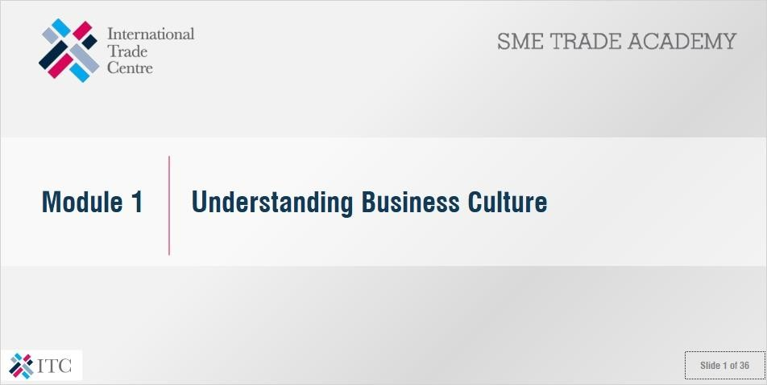

# *Objectives*

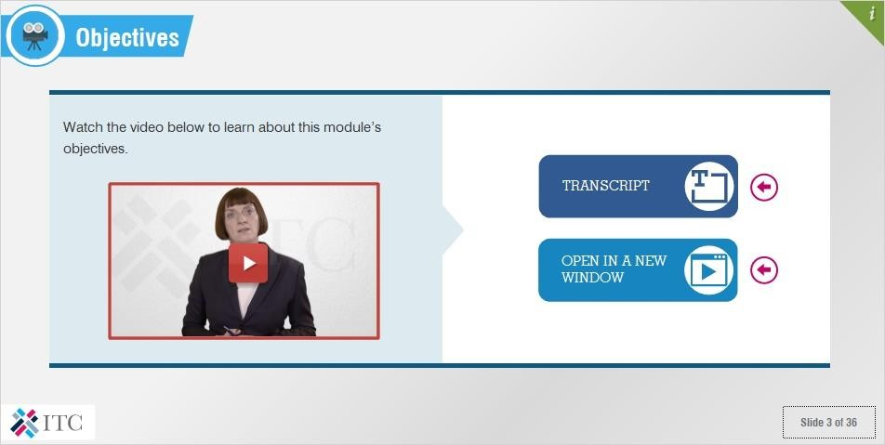

**Video:** [**https://www.youtube.com/watch?v=21DYwlioXB0**](https://www.youtube.com/watch?v=21DYwlioXB0)

**Transcript:** *Da jia hao*. My name is Barbara Geldermann. I am your personal advisor for this course: “Doing business in a Chinese Cultural Context”.

So, why me and why China?

I have a long experience with China and the Chinese culture. I studied Sinology and the history of art and comparative religious studies in Germany and Chinese Taipei. Since visiting the country in 1990, I have been able to witness firsthand the remarkable rise of China, which has today become one of the world’s major economies.

Today, I am a senior management advisor for Chinese and German companies. In addition to my work with business people, I teach Intercultural Management for undergraduate and graduate students at the University of

Applied Science Berlin (HTW).

This course will help you to prepare and perform in an intercultural setting in order to optimize your collaboration with partners from China.

Consequently, the main objective of this course is to enable you to develop an understanding of China’s cultural values and the influence that they have on management activities. This will enhance your ability to effectively communicate, interact and behave in a Chinese business environment. Above all, it will help you to be successful!

If you want to be successful in business in a Chinese cultural context, you will need to develop an understanding of yourself and the influence which your own cultures - national, company, professional and regional - have on your patterns of thinking and behavior. This is our starting point: Module 1, which you are viewing now.

Then, in Module 2, we will examine the culture of your potential Chinese business partners in order to understand the different ways in which they think about and do business. This module will stress the importance of engaging with individuals rather than relying on dangerous generalizations and stereotypes, and will provide you with a range of communication strategies for key business contexts such as meetings, presentations, written communication and social situations.

Finally, Module 3 will help you to apply the knowledge that you have gained in the first 2 modules in different settings, such as attending a trade fair or meeting a Chinese businessperson in your country.

I hope that you enjoy this course, and wish you good luck over the coming weeks.

# *Introduction*

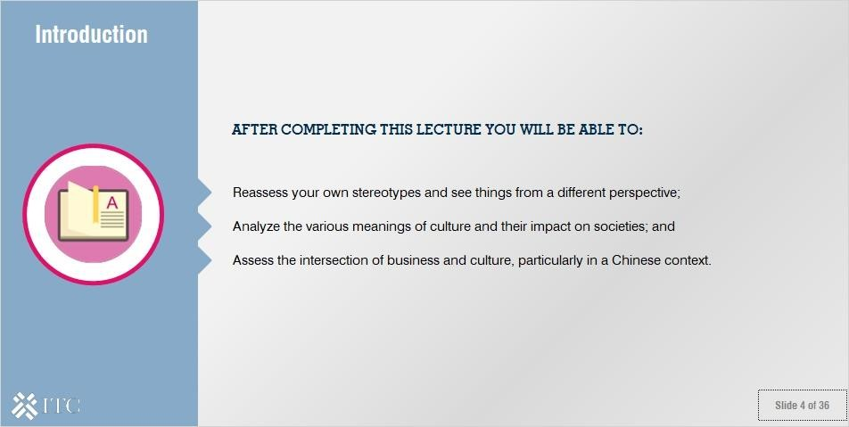

After completing this lecture you will be able to:

* Reassess your own stereotypes and see things from a different perspective;
* Analyze the various meanings of culture and their impact on societies; and
* Assess the intersection of business and culture, particularly in a Chinese context.

# *Contributors*

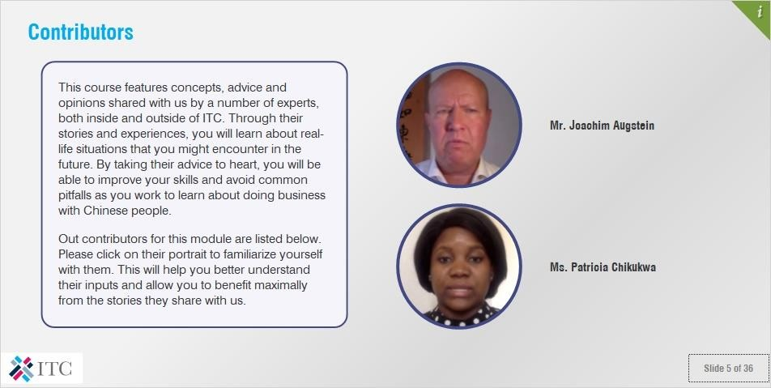

## Notes:

This course features concepts, advice and opinions shared with us by a number of experts, both inside and outside of ITC. Through their stories and experiences, you will learn about real-life situations that you might encounter in the future. By taking their advice to heart, you will be able to improve your skills and avoid common pitfalls as you work to learn about doing business with Chinese people.

Out contributors for this module are listed below. Please click on their portrait to familiarize yourself with them. This will help you better understand their inputs and allow you to benefit maximally from the stories they share with us.

# *Stereotypes, Perception and Culture*

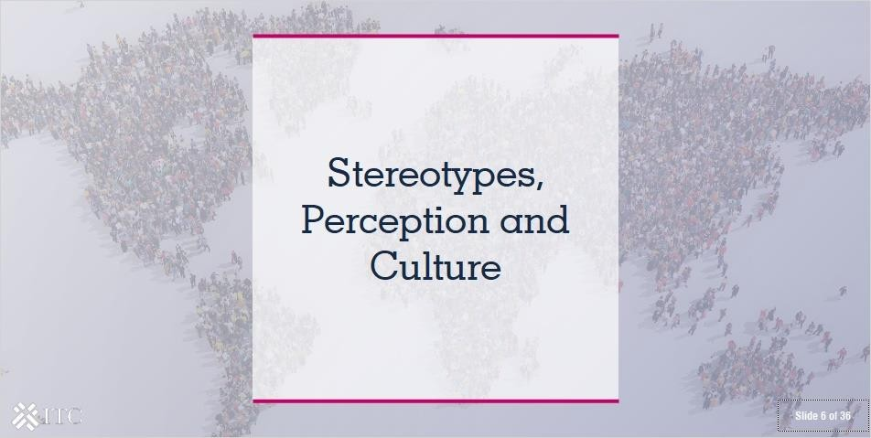

* 1. ***Answer the question***

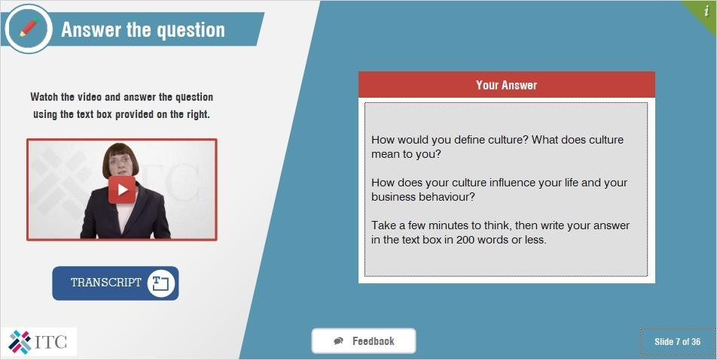

**Video:** [**https://www.youtube.com/watch?v=ggdt0g4xDHM**](https://www.youtube.com/watch?v=ggdt0g4xDHM)

**Transcript:** We all have the same needs and are confronted with the same problems. However, the methods and means that we use to address these problems vary from culture to culture.

So, I would like to ask you: how would you define culture? What does culture mean to you? How does your culture influence your life and your business behaviour?

Takes a few minutes to think, then write your answer in the text box in 200 words or less.

## Feedback:

There are a number of things that all small businesses have to keep in mind when entering the Chinese market. We will look at them in greater detail in the following slides, but basically, you need to keep in mind that you will need to fulfil a number of basic requirements. These include obtaining the correct customs documents, meeting all tariff and non-tariff requirements, such as regulations for the food and textile sectors, as well as obtaining all of the standards and certifications particular to the Chinese marketplace.

We will also briefly talk about other relevant considerations, such as sector-specific technical requirements. But, let’s begin with customs requirements and tariffs required to import into China.

# *Being self-aware with regard to stereotypes*

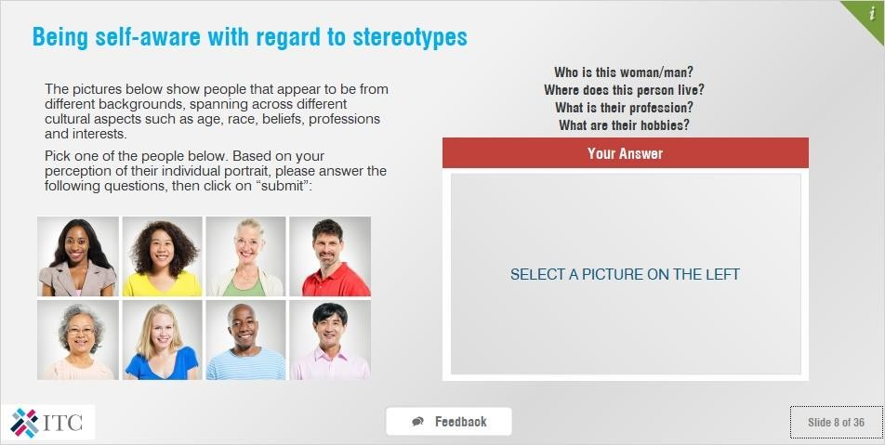

## Notes:

The pictures below show people that appear to be from different backgrounds, spanning across different cultural aspects such as age, race, beliefs, professions and interests.

Pick one of the people below. Based on your perception of their individual portrait, please answer the following questions, then click on “submit”:

* Who is this woman/ man?
* Where does this person live?
* What is their profession?
* What are their hobbies?

### Feedback:

It would be very difficult to verify whether your description of each picture correctly describes the person behind the photo. But what I can tell you is that everyone has their own preconceptions and stereotypes about the world. This is a natural human instinct, without which we could not make inferences and consequently would not survive long. For example, a child who sees a blackbird may think all birds look like blackbirds, until he or she realizes that penguins, eagles and ducks are also birds. In the same way, we continuously have to adjust our preconceptions to the reality of our life experiences.

# *Dealing with Stereotypes*

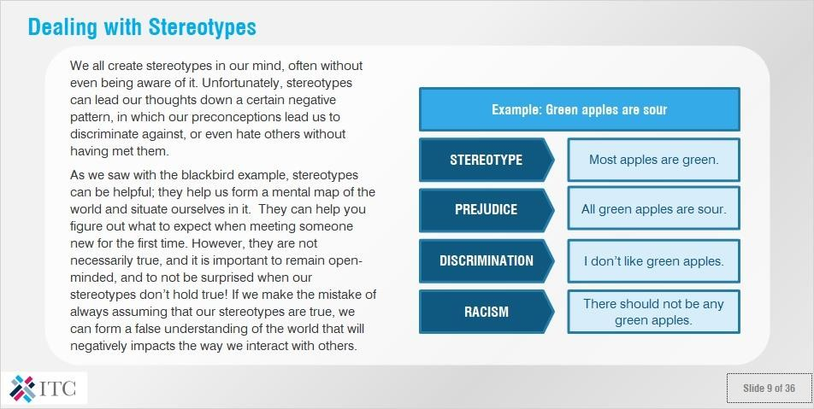

## Notes:

We all create stereotypes in our mind, often without even being aware of it. Unfortunately, stereotypes can lead our thoughts down a certain negative pattern, in which our preconceptions lead us to discriminate against, or even hate others without having met them.

Here, we can see how people can create stereotypes about something as mundane as apples, sometimes without even being consciously aware of it.

As we saw with the blackbird example, stereotypes can be helpful; they help us form a mental map of the world and situate ourselves in it. They can help you figure out what to expect when meeting someone new for the first time.

However, they are not necessarily true, and it is important to remain open-minded, and to not be surprised when our stereotypes don’t hold true! If we make the mistake of always assuming that our stereotypes are true, we can form a false understanding of the world that will negatively impacts the way we interact with others.

# *Answer the question*

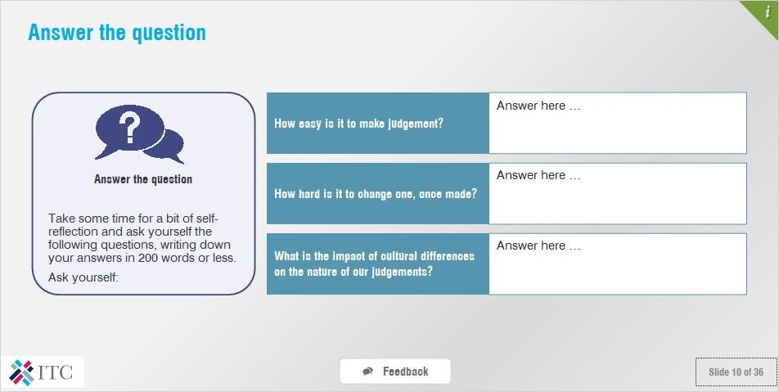

## Notes:

Take some time for a bit of self-reflection and ask yourself the following questions, writing down your answers in 200 words or less.

Ask yourself:

* How easy is it to make a judgement?
* How hard is it to change one, once made?
* What is the impact of cultural differences on the nature of our judgements?

### Feedback:

Thank you for your answer. It is surprisingly easy for us to pass judgement, even when we do not have all of the facts. The trick is to be able to change our opinions, and thus the judgements we have made, once we are presented with new information. Culture and cultural differences can impact on our judgements in several ways, most particularly through the way we form and respond to stereotypes that we hold in our minds. Remember that not all stereotypes are true, and that stereotypes can sometimes lead you down a negative path.

# *Test your perception*

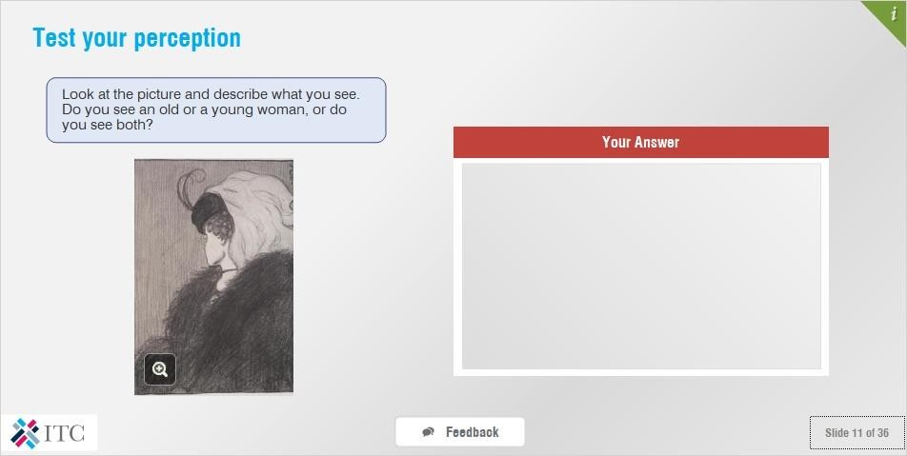

## Notes:

Look at the picture and describe what you see. Do you see an old or a young woman, or do you see both?

### Feedback:

Thank you. “Perception” is commonly defined as the awareness of something through the senses. It is thus different for everyone. Some people perceive the picture above as an old woman, others see a young woman, and some people see both immediately.

# *Why is perception important?*

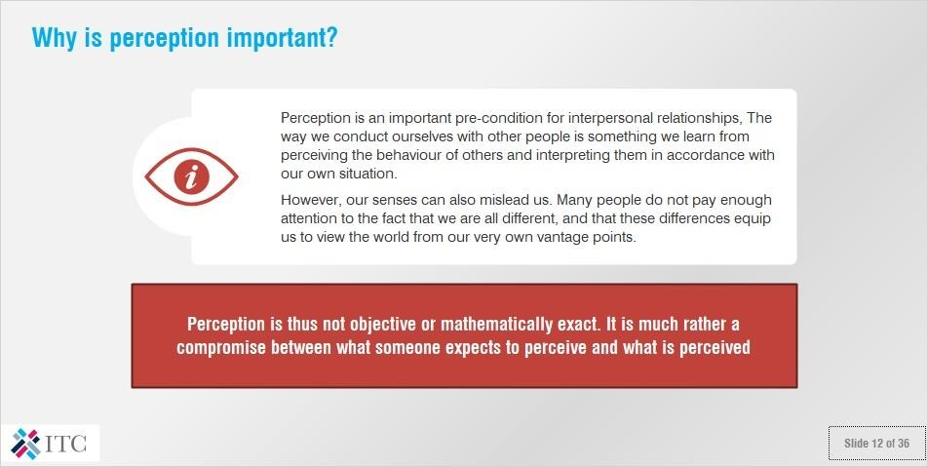

## Notes:

Perception is an important pre-condition for interpersonal relationships. The way we conduct ourselves with other people is something we learn from perceiving the behaviour of others and interpreting them in accordance with our own situation.

However, our senses can also mislead us. Many people do not pay enough attention to the fact that we are all different, and that these differences equip us to view the world from our very own vantage points.

Perception is thus not objective or mathematically exact. It is much rather a compromise between what someone expects to perceive and what is perceived.

# *Test your perception*

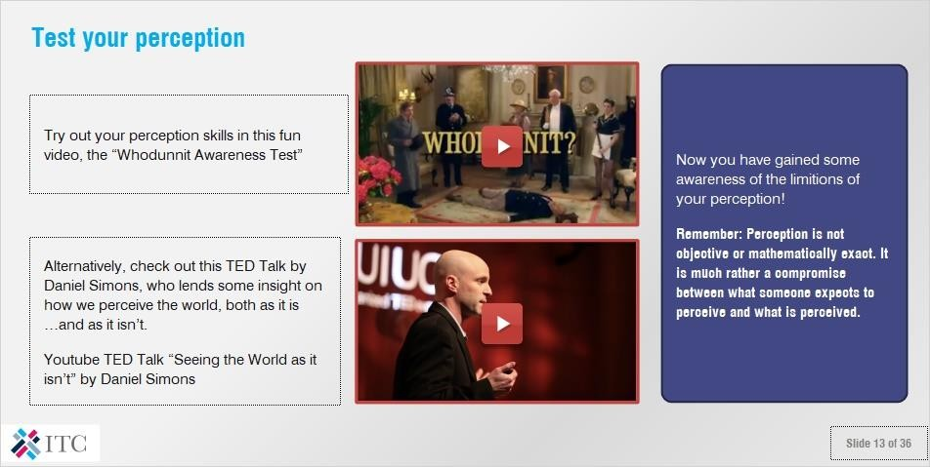

## Notes:

Try out your perception skills in this fun video, the “Whodunnit Awareness Test” <https://www.youtube.com/watch?v=ubNF9QNEQLA>

Alternatively, check out this TED Talk by Daniel Simons, who lends some insight on how we perceive the world, both as it is…and as it isn’t.

Youtube TED Talk “Seeing the World as it isn’t” by Daniel Simons <https://www.youtube.com/watch?time_continue=17&v=9Il_D3Xt9W0>

Now you have gained some awareness of the limitations of your perception!

### Remember: Perception is not objective or mathematically exact. It is much rather a compromise between what someone expects to perceive and what is perceived.

* 1. ***The Iceberg Model of Culture***

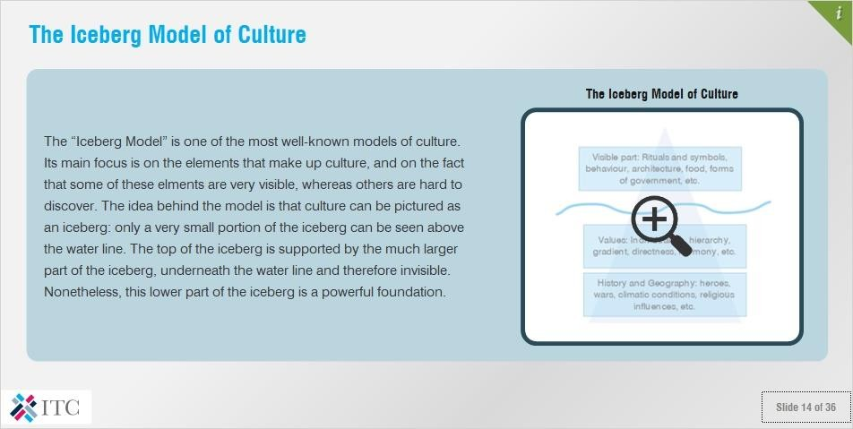

**Notes:**

The “Iceberg Model” is one of the most well-known models of culture. Its main focus is on the elements that make up culture, and on the fact that some of these elements are very visible, whereas others are hard to discover. The idea behind the model is that culture can be pictured as an iceberg: only a very small portion of the iceberg can be seen above the water line. The top of the iceberg is supported by the much larger part of the iceberg, underneath the water line and therefore invisible. Nonetheless, this lower part of the iceberg is a powerful foundation.

THE DEVELOPMENT OF CULTURE

As with an iceberg, it is only possible to perceive the surface of another culture. The remaining, submerged, parts of culture consist of values that are shaped by history and geography. Individuals are shaped by their experiences, and this happens to entire groups and populations in much the same way. As an example, countries with changing seasons tend to adhere to planning processes more strictly. Historically, this was for survival purposes, as it was necessary to thoroughly plan harvest and food storage. Values, such as punctuality, rose out of this necessity, and last to this day. This ultimately influences our behaviour.

# *Intercultural misunderstanding 1/2*

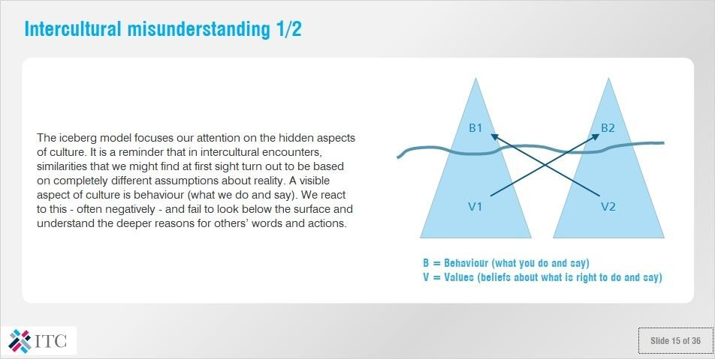

## Notes:

The iceberg model focuses our attention on the hidden aspects of culture. It is a reminder that in intercultural encounters, similarities that we might find at first sight turn out to be based on completely different assumptions about reality. A visible aspect of culture is behaviour (what we do and say). We react to this - often negatively - and fail to look below the surface and understand the deeper reasons for others’ words and actions.

# *Intercultural misunderstanding 2/2*

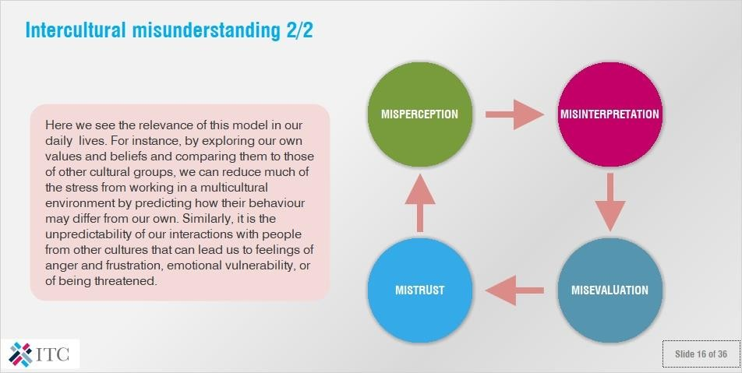

## Notes:

Here we see the relevance of this model in our daily lives. For instance, by exploring our own values and beliefs and comparing them to those of other cultural groups, we can reduce much of the stress from working in a multicultural environment by predicting how their behaviour may differ from our own. Similarly, it is the unpredictability of our

interactions with people from other cultures that can lead us to feelings of anger and frustration, emotional vulnerability, or of being threatened.

# *Exercise: example intercultural misunderstanding*

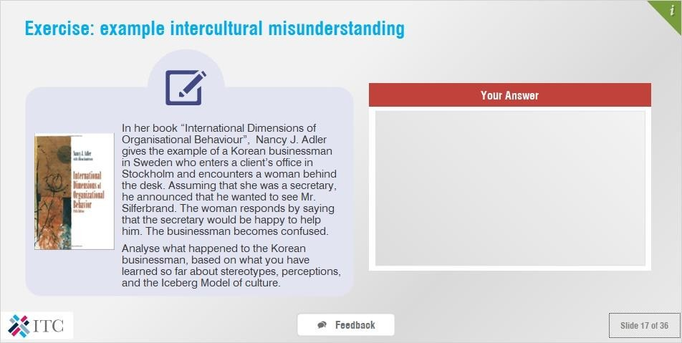

## Notes:

In her book “International Dimensions of Organisational Behaviour”, Nancy J. Adler gives the example of a Korean businessman in Sweden who enters a client’s office in Stockholm and encounters a woman behind the desk.

Assuming that she was a secretary, he announced that he wanted to see Mr. Silferbrand. The woman responds by saying that the secretary would be happy to help him. The businessman becomes confused.

Analyse what happened to the Korean businessman, based on what you have learned so far about stereotypes, perceptions, and the Iceberg Model of culture.

### Feedback:

Thank you. In assuming that most women are secretaries rather than managers, the Korean businessman misinterpreted the situation and acted inappropriately. His assumption makes sense because most women in Korean offices are secretaries. However, it proved counterproductive to his situation since this particular woman was not a secretary.

A saying from the Jewish Talmud says:

“We do not see things as they are, we see things as we are.“

It means that we see things as they are, but filtered through our perceptions. Our culture and values provide some of the key filters that distort, block and even create what we choose to see or hear. For instance in business, we try to interpret the behaviour of a foreign business partner using our own cultural filters and don’t try to switch to their perspective. We might thus interpret the situation in a negative way, according to our own beliefs and values.

Because of our negative evaluation, we begin mistrusting this partner, which in turn leads to us looking and listening for confirmation of our own negative impressions.

# *Framework for Understanding: Cultural Orientations*

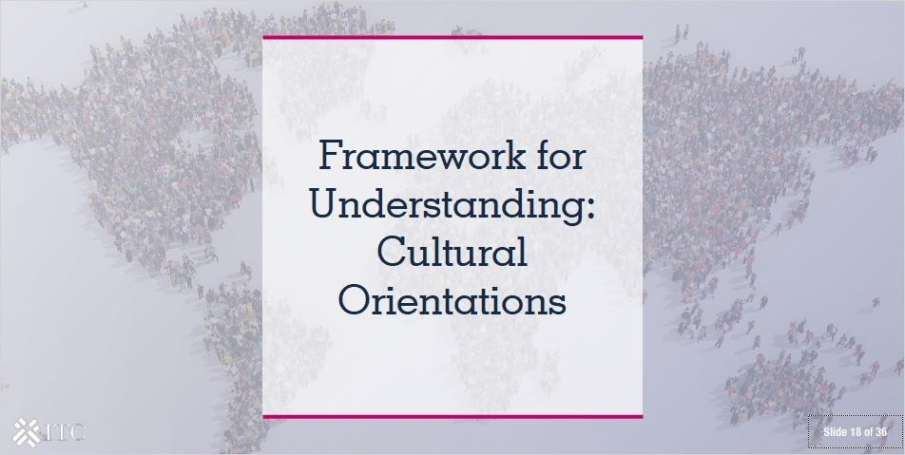

* 1. ***What is culture for you?***

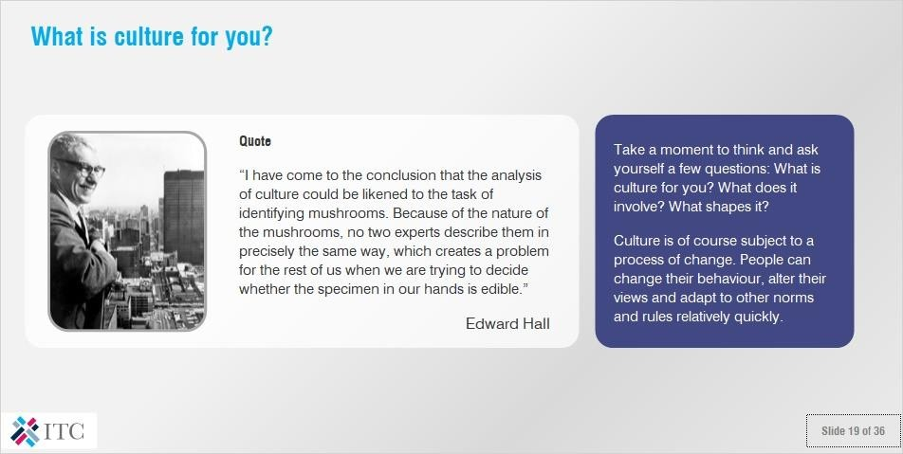

## Notes:

Quote: “I have come to the conclusion that the analysis of culture could be likened to the task of identifying mushrooms. Because of the nature of the mushrooms, no two experts describe them in precisely the same way, which creates a problem for the rest of us when we are trying to decide whether the specimen in our hands is edible.” -- Edward Hall

Take a moment to think and ask yourself a few questions: What is culture for you? What does it involve? What shapes it?

Culture is of course subject to a process of change. People can change their behaviour, alter their views and adapt to other norms and rules relatively quickly.

# *Conceptualizing culture*

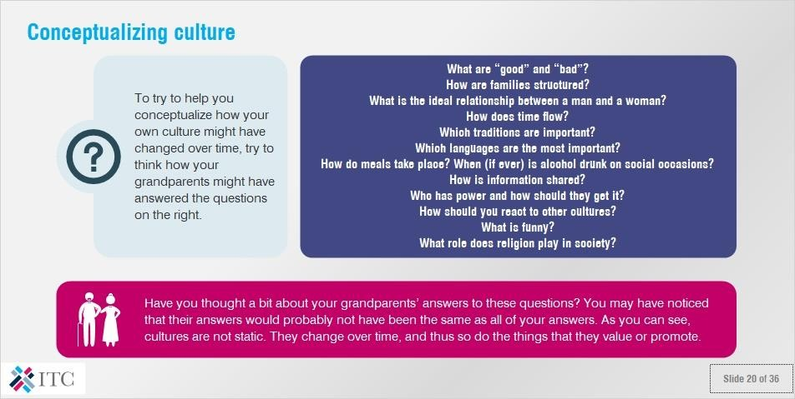

## Notes:

To try to help you conceptualize how your own culture might have changed over time, try to think how your grandparents might have answered the questions below.

* What are “good” and “bad”?
* How are families structured?
* What is the ideal relationship between a man and a woman?
* How does time flow?
* Which traditions are important?
* Which languages are the most important?
* How do meals take place? When (if ever) is alcohol drunk on social occasions?
* How is information shared?
* Who has power and how should they get it?
* How should you react to other cultures?
* What is funny?
* What role does religion play in society?

Have you thought a bit about your grandparents’ answers to these questions? You may have noticed that their answers would probably not have been the same as all of your answers. As you can see, cultures are not static. They change over time, and thus so do the things that they value or promote.

# *The major elements of culture*

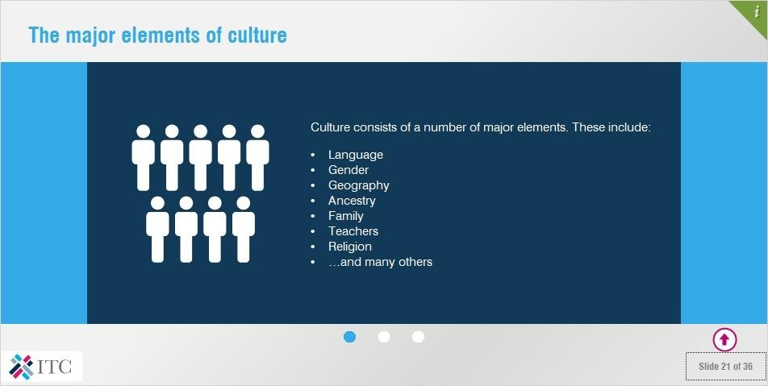

## Notes:

Culture consists of a number of major elements. These include:

* Language
* Gender
* Geography
* Ancestry
* Family
* Teachers
* Religion
* …and many others

However, this is just scratching the complexity of culture, as culture is not only determined ethnic or national heritage. When we try to define our culture, we should remember that it is not only our cultural identity that is constantly changing, it is also a network of different cultural influences that are interwoven with it numerous ways. In this way, people of differing nationalities may differ in several areas, such as through their affiliation with a particular gender, age group, or social class, but maintain cultural similarities which transcend national borders.

It is very important to keep in mind that cultural orientations are only constructs which, even if correct, merely show a tendency and are never a complete expression of reality.

### The “layer cake” metaphor

Each and every one of us is like a cake with many layers of flavours.

Our life experiences, personal beliefs and the history of our family define what kind of cake we are. It is the same way with culture.

# *Culture and cultural orientations*

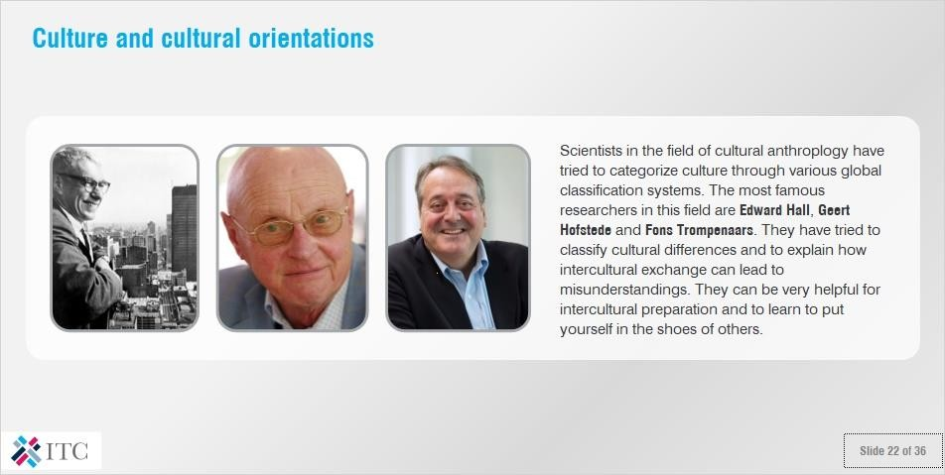

## Notes:

Scientists in the field of cultural anthropology have tried to categorize culture through various

global classification systems. The most famous researchers in this field are Edward Hall, Gerd Hofstede and Fons Trompenaars. They have tried to classify cultural differences and to explain how intercultural exchange can lead to misunderstandings. They can be very helpful for intercultural preparation and to learn to put yourself in the shoes of others.

# *Exercise: Understanding your own cultural tendencies*

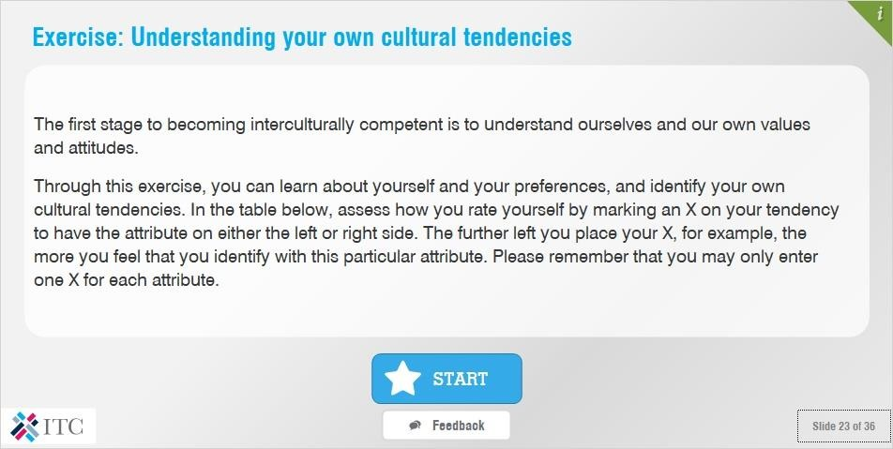

## Notes:

The first stage to becoming interculturally competent is to understand ourselves and our own values and attitudes.

Through this exercise, you can learn about yourself and your preferences, and identify your own cultural tendencies. In the table below, assess how you rate yourself by marking an X on your tendency to have the attribute on either the left or right side. The further left you place your X, for example, the more you feel that you identify with this particular attribute. Please remember that you may only enter one X for each attribute.

(note: this exercise is not available in the PDF version of this lecture)

### Feedback:

Thank you. Through your answers, we see your particular cultural makeup. You are oriented towards…

To what extent do you think that your answers were influenced by your particular ethnic, religious or geographic location? To what extent do you think that they were influenced by your family, or your own personality? As we have seen, “culture” as a concept is fluid and changes over time. What’s more, it is not limited to nationalities, as different organizations or social groups also often have their own cultures.

In the following slides, we will look at the interaction of culture with business, and look at some strategies to work successfully across cultures.

# *Business and Culture*

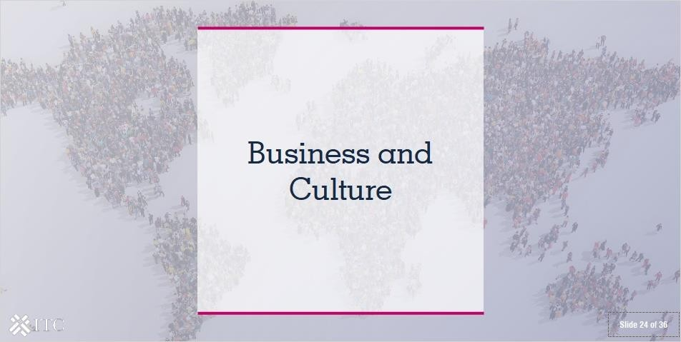

* 1. ***Answer the question***

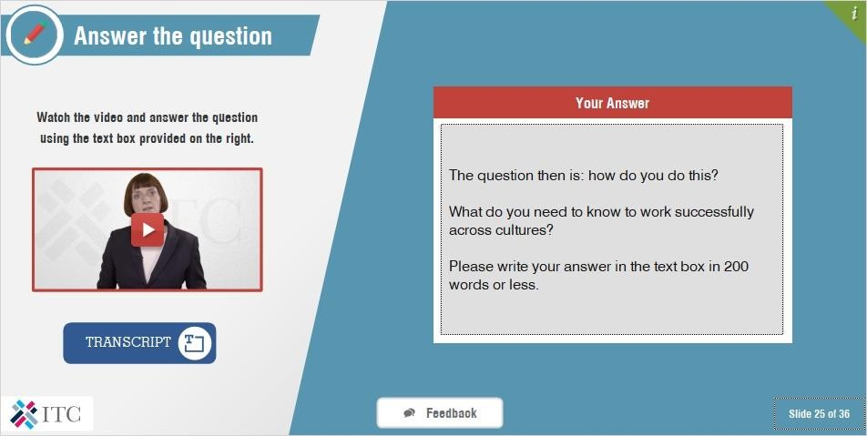

**Video:** <https://www.youtube.com/watch?v=njmepP2mIHQ>

## Transcript:

There is a lot of evidence to show that the world’s cultures are becoming increasingly interconnected, and that the business world is becoming increasingly global. As economic barriers come down, cultural barriers are becoming a major factors in international trade. They provide both challenges and opportunities for business. This is because, when cultures come into contact, while they may converge in some aspects, but diverge in others.

But culture is not only national. Each institution or business has its own specific, sometimes industry-specific, and often internationally-influenced culture. Companies as well as state, religious or private institutions each form different kinds of business cultures, due to the fact that their ethics, goals, framework conditions and organization

forms are different. There are organizational cultures in societies, companies, institutions and families which are steep and hierarchical, and there are others with more flat organizational structures. As such, it is not enough for you to understand “Chinese culture” - you will need to learn about the culture of the particular group or organization with which you are dealing.

The question then is: how do you do this? What do you need to know to work successfully across cultures? Please write your answer in the text box in 200 words or less.

## Feedback:

There are a number of things that all small businesses have to keep in mind when entering the Chinese market. We will look at them in greater detail in the following slides, but basically, you need to keep in mind that you will need to fulfil a number of basic requirements. These include obtaining the correct customs documents, meeting all tariff and non-tariff requirements, such as regulations for the food and textile sectors, as well as obtaining all of the standards and certifications particular to the Chinese marketplace.

We will also briefly talk about other relevant considerations, such as sector-specific technical requirements. But, let’s begin with customs requirements and tariffs required to import into China.

# *What makes a business culture*

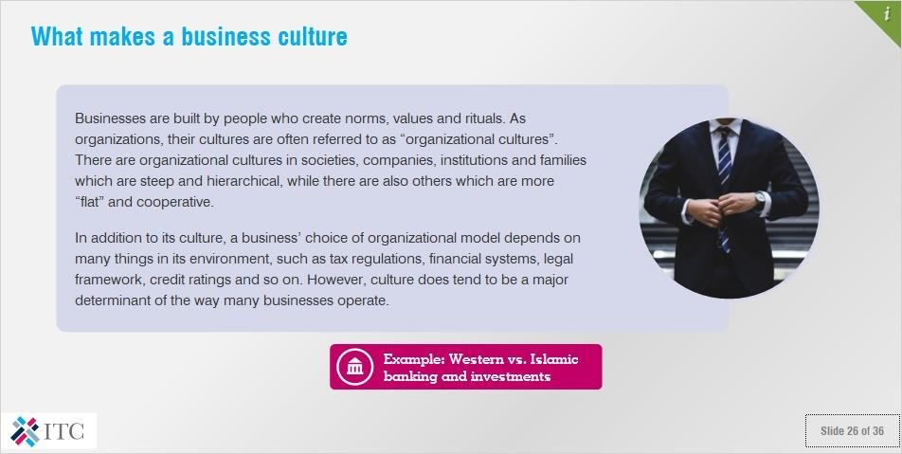

## Notes:

Businesses are built by people who create norms, values and rituals. As organizations, their cultures are often referred to as “organizational cultures”. There are organizational cultures in societies, companies, institutions and families which are steep and hierarchical, while there are also others which are more “flat” and cooperative.

In addition to its culture, a business’ choice of organizational model depends on many things in its environment, such as tax regulations, financial systems, legal framework, credit ratings and so on. However, culture does tend to be a major determinant of the way many businesses operate.

### Example: Western vs. Islamic banking and investments

In the West, bank customers expect to receive interest on their deposits. In Islamic banking, the Qur’an prohibits paying or receiving interest; this is seen as taking advantage of others who are less fortunate. Instead, bank customers entrust funds to banks in exchange for profit-sharing (*mudaraba*). Meanwhile, in the West, stock market transactions are open to

investments and speculation in almost anything.

As you can see, some cultural groups may have completely opposing behaviors or cultural orientations. In this case, it is not easy how the Islamic and western banking attitudes can be reconciled.

Under Islamic law, only investments in economic activities that are consistent with the values of Islam are acceptable (halal). Therefore, many western banks have problems when providing services for Muslims.

Consider: What is the impact of such differences when doing business across borders?

# *Example of Chinese business culture: the East Hope Group*

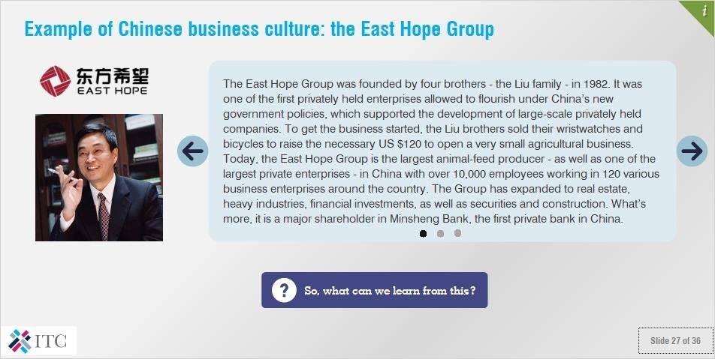

## Notes:

The East Hope Group was founded by four brothers - the Liu family - in 1982. It was one of the first privately held enterprises allowed to flourish under China’s new government policies, which supported the development of large-scale privately held companies. To get the business started, the Liu brothers sold their wristwatches and bicycles to raise the necessary US $120 to open a very small agricultural business. Today, the East Hope Group is the largest animal-feed producer - as well as one of the largest private enterprises - in China with over 10,000 employees working in 120 various business enterprises around the country. The Group has expanded to real estate, heavy industries, financial investments, as well as securities and construction. What’s more, it is a major shareholder in Minsheng Bank, the first private bank in China.

The four brothers and their family jointly own the East Hope Group Corporation Ltd., while each brother heads one of the firm’s four separate and highly diversified divisions. Interestingly, and somewhat unusually, the family’s recognized head is not the eldest, but the third brother, Liu Yongxing.

Liu family members can be found throughout key executive and managerial positions in all four divisions. When important decision arise, family members meet to discuss strategies and tactics and make decisions about the future course of action that should be taken. These decisions are relayed to lower-level non-family employees for implementation. The original company motto remains:

“Help the farmers succeed, meet the needs of city residents, and contribute to the country’s development.”

### So, what can we learn from this?

The East Hope Group has a clear national culture, as well as a corporate culture, which differ significantly from those of the typical firms found in the US, UK, and Canada.

Not surprisingly, this has led to differences in the way the East Hope Group approaches strategic and structural decisions. The company exists in an Eastern society (China) that stresses collectivism, hierarchy and family control. Employees are not expected to, and may not openly criticize the owner/managers (family members).

This is rather common in a Chinese cultural context, in which the family is the foundation of most organizations, including businesses! Indeed, even for Chinese people outside the People´s Republic of China, the family-based business model remains the dominant model of organization. Paradoxically, the People’s Republic of China had long discouraged family- based business models, but these have been increasing in recent decades since the country’s opening up of its economy to the rest of the world. Interestingly though, the East Hope Group also seems to have a few quirks of its own. Unusually for a Chinese organization, it is not the oldest brother who is the recognized head! Keep in mind, then, that while national cultures do provide a certain cultural baseline, to truly understand a business partner, you will have to look at their individual corporate culture as well.

# *The importance of understanding your business partner’s culture*

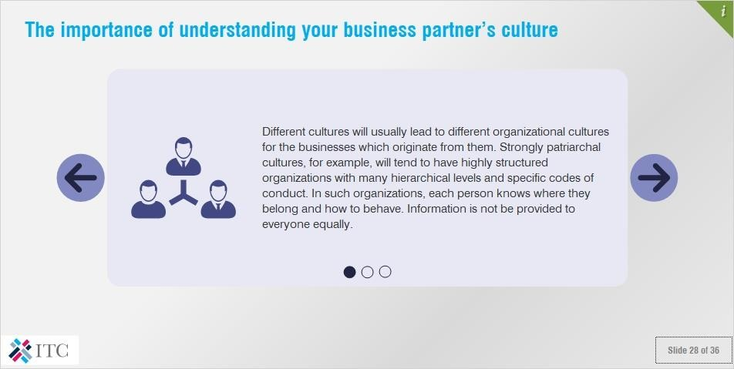

## Notes:

Different cultures will usually lead to different organizational cultures for the businesses which originate from them. Strongly patriarchal cultures, for example, will tend to have highly structured organizations with many hierarchical levels and specific codes of conduct. In such organizations, each person knows where they belong and how to behave.

Information is not be provided to everyone equally.

On the other hand, other, more egalitarian cultures will tend to produce business with “flatter” hierarchies, in which t he ability to individually anticipate the required work processes of a particular project are highly prized. In such organizations, employees are expected to begin tasks and carry them out with a sense of individual responsibility.

Information tends to be provided to everyone more-or-less equally.

If your business partner is from a different business culture than your own, their cultural background will become highly influential in your dealings. For example, if you do not know the specific culture of your business partner, you may have a difficult time finding out who is really in charge of decision-making, or how to approach lower-level executives with proposals. In the end, such avoidable blunders can cost you a lot of money.

# *Cultural Influences on Organizational Design*

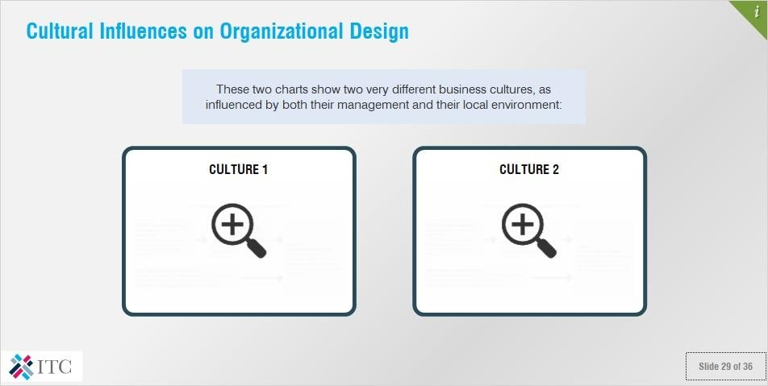

## Notes:

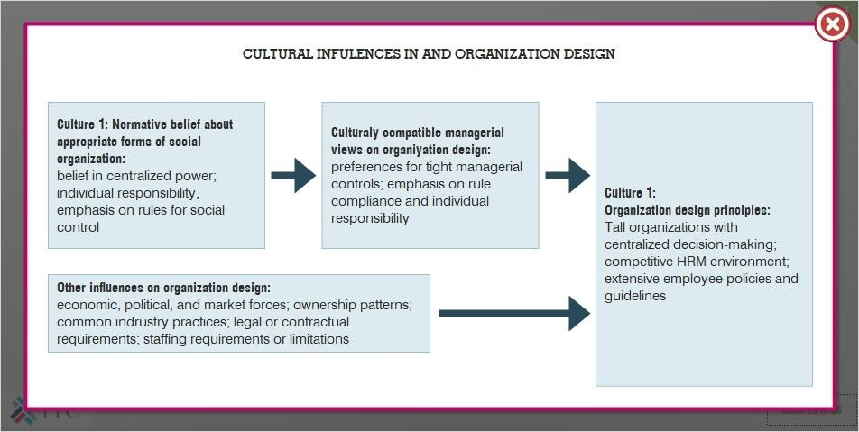These two charts show two very different business cultures, as influenced by both their management and their local environment:

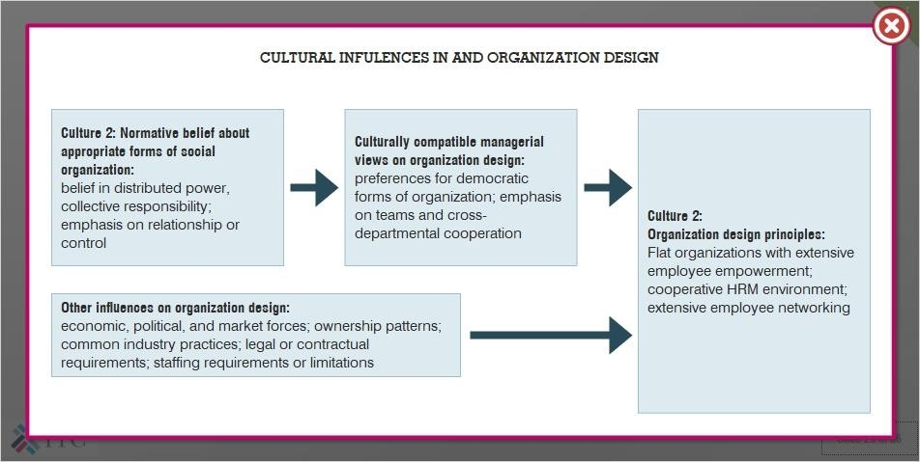

# *Exercise: Answer the following questions*

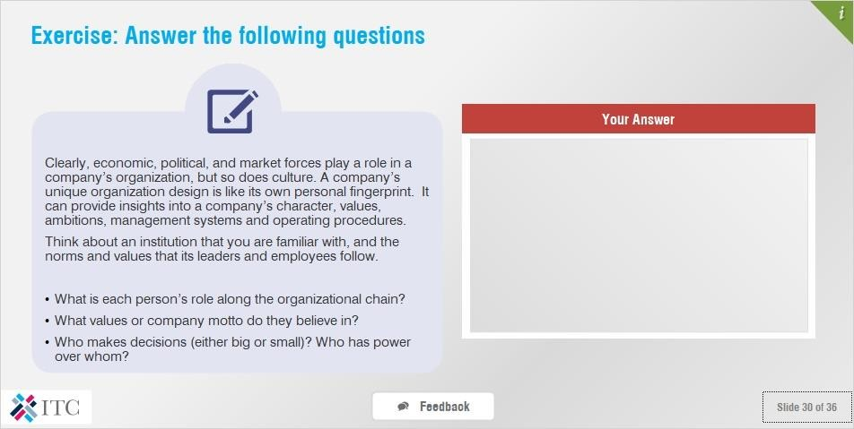

## Notes:

Clearly, economic, political, and market forces play a role in a company’s organization, but so does culture. A company’s unique organization design is like its own personal fingerprint. It can provide insights into a company’s character, values, ambitions, management systems and operating procedures.

Think about an institution that you are familiar with, and the norms and values that its leaders and employees follow.

* What is each person’s role along the organizational chain?
* What values or company motto do they believe in?
* Who makes decisions (either big or small)? Who has power over whom?

### Feedback:

Thank you. Was the company that you thought about more egalitarian, or hierarchical? Where was it from, and in what way do you think the culture of its country of origin influenced its corporate culture? All of these are interesting questions for you to ponder, as you deepen your understanding of the interaction of culture and business.

# *Exercise: Answer the following questions*

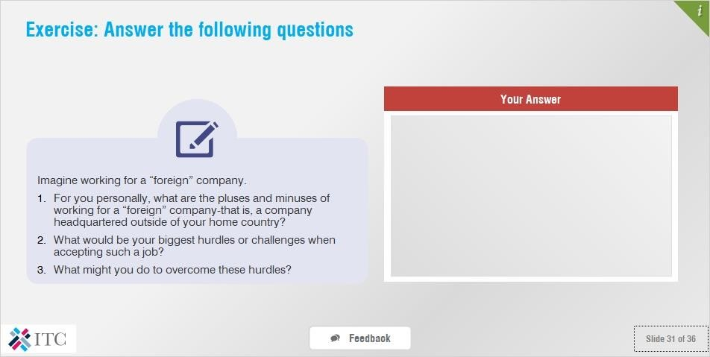

## Notes:

Imagine working for a “foreign” company.

1. For you personally, what are the pluses and minuses of working for a “foreign” company-that is, a company headquartered outside of your home country?
2. What would be your biggest hurdles or challenges when accepting such a job? 3.What might you do to overcome these hurdles?

### Feedback:

Thank you. Hopefully, thinking about these issues prompted you to think about the way in which the business culture in your country might be different from those in different countries. If you are used to a more hierarchical way of doing business, for example, you might feel uncomfortable with the degree of uncertainty and flexibility that would be expected from you in a more egalitarian structure. Conversely, if the most egalitarian structure is what you are used to, you might chafe at the restrictions imposed upon you by your superiors in a more hierarchical company.

In all cases, though, you need to be able to understand and try to put yourself in the shoes of your business partner’s culture if you want to be successful doing business internationally.

# *Conclusion and Wrap-up*

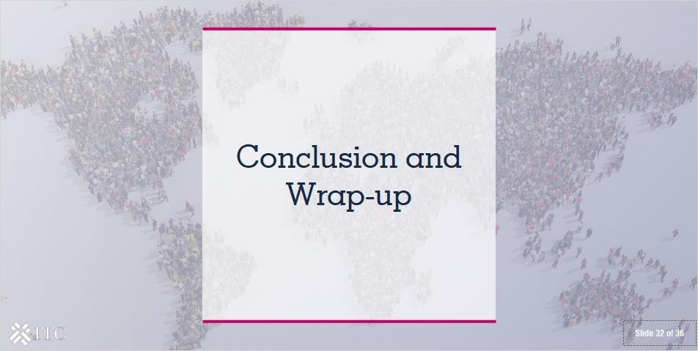

* 1. ***Answer the question***

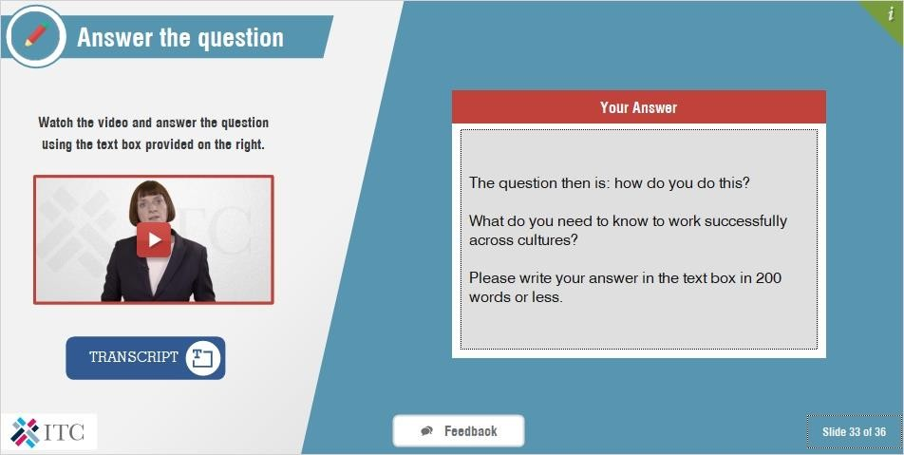

**Video:** [**https://www.youtube.com/watch?v=cHlgfjvQp1k**](https://www.youtube.com/watch?v=cHlgfjvQp1k)

**Transcript:**

In this module, we have looked at the interrelations between business and culture. People around the world organize and motivate themselves, make decisions, communicate, and negotiate in different ways. You have now seen that business cultures can be very different and that, to be successful in doing business internationally, you will need to develop an understanding of different business cultures and values. Without appropriate preparation and a good strategy, your inter-cultural business interactions could end in failure.

So, here, I would like you to think: what have you learned about how to deal with different business cultures? Conversely, what could happen if you are not aware, or not prepared to understand the culture of your business partners? Please write your answer in the text box in 200 words or less.

## Feedback:

There are a number of things that all small businesses have to keep in mind when entering the Chinese market. We will look at them in greater detail in the following slides, but basically, you need to keep in mind that you will need to fulfil a number of basic requirements. These include obtaining the correct customs documents, meeting all tariff and non-tariff requirements, such as regulations for the food and textile sectors, as well as obtaining all of the standards and certifications particular to the Chinese marketplace.

We will also briefly talk about other relevant considerations, such as sector-specific technical requirements. But, let’s begin with customs requirements and tariffs required to import into China.

# *Wrapping up*

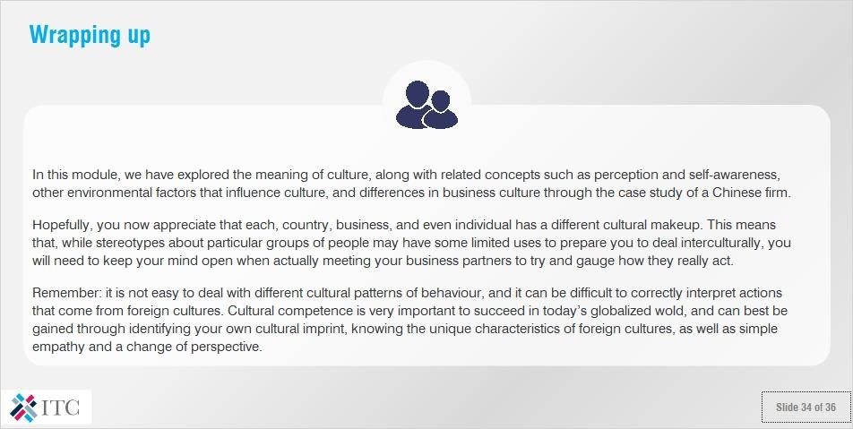

## Note:

In this module, we have explored the meaning of culture, along with related concepts such as perception and self- awareness, other environmental factors that influence culture, and differences in business culture through the case study of a Chinese firm.

Hopefully, you now appreciate that each, country, business, and even individual has a different cultural makeup. This means that, while stereotypes about particular groups of people may have some limited uses to prepare you to deal interculturally, you will need to keep your mind open when actually meeting your business partners to try and gauge how they really act.

Remember: it is not easy to deal with different cultural patterns of behaviour, and it can be difficult to correctly interpret actions that come from foreign cultures. Cultural competence is very important to succeed in today’s globalized world, and can best be gained through identifying your own cultural imprint, knowing the unique characteristics of foreign cultures, as well as simple empathy and a change of perspective.

# *Exercise: Answer the following questions*

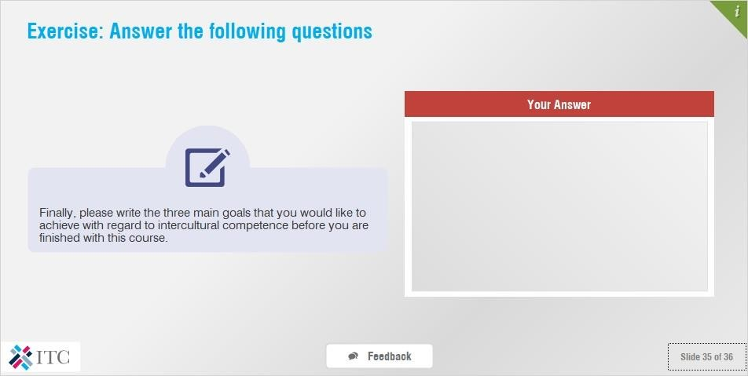

## Notes:

Finally, please write the three main goals that you would like to achieve with regard to intercultural competence before you are finished with this course.

### Feedback:

Thank you. I hope that I will be able to assist you to achieve these goals before you are done with this course. If you have any questions with regard to the content of the lectures, or if you would like additional discussion or pointers towards the fulfilment of your goals, I encourage you to post on the course’s forum task, or to contact me privately on the course page.

# *Thank you for completing the lecture*

